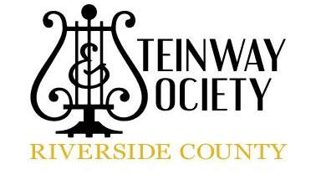

Steinway Society of Riverside County
2024 Awards Festival

Application Form

NAME_________________________________________________BIRTHDATE___________

ADDRESS_______________________________CITY__________________ZIP___________

PHONE___________________________________EMAIL_____________________________

GRADE______________INSTRUCTOR___________________________________________

INSTRUCTOR’S ADDRESS_______________________________CITY__________________ZIP___________

INSTRUCTOR’S PHONE_________________________EMAIL_______________________

REPERTOIRE:

COMPOSER TITLE - INCLUDE MOV’T, OP., KEY ETC. EXACT TIME

MC______________________________ __________________________________________

MC_________________________________________________________________________

REC

PLEASE INCLUDE ALL INFO REQUESTED FOR REPERTOIRE!!!

PLEASE REMEMBER TO INCLUDE BIOGRAPHY AND A $50 CHECK.

MUST BE POSTMARKED BY FEB 2, 2024!

PLEASE MAIL COMPLETE APPLICATION PACKAGE TO:

STEINWAY SOCIETY OF RIVERSIDE COUNTY
c/o JAMES MCCORMICK
2980 N. STARR RD.
PALM SPRINGS, CA, 92262

